# Objective

You will experiment with altering the parameters passed to a method to change the results produced. You will also be exposed to random number generation.

## Topics: methods, parameters, random values

# Instructions

You will create a sketch that paints the word “hello” on the screen in random positions and colors. You will need to make use of the following methods:

color **color(**float r, float b, float g[, float a]**)** – returns a color variable with the specified red, green, and blue values, and optionally the specified alpha (i.e. transparency)

void **fill(**color c**)** – sets the color of the shapes and text to be drawn

void **text(**String msg, float x, float y**)** – draws a String at a specified location

float **random(**float lower, float upper**)** – returns a random number in the range [lower, upper)

# Examples

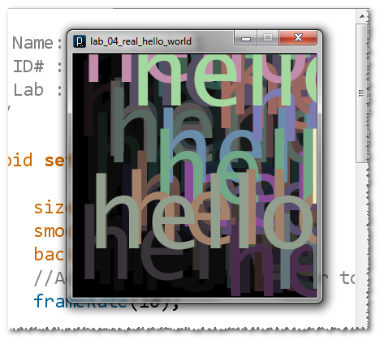

# Hints

The red, green, blue and alpha components of a color must be in the range [0, 255].

# Challenge

Try drawing a rectangle as big as the full sketch, filled with a solid, mostly transparent color before each **text()** method call.